TOUR OF CATHEDRAL BASILICA OF THE SACRED HEART
NEWARK, NEW JERSEY

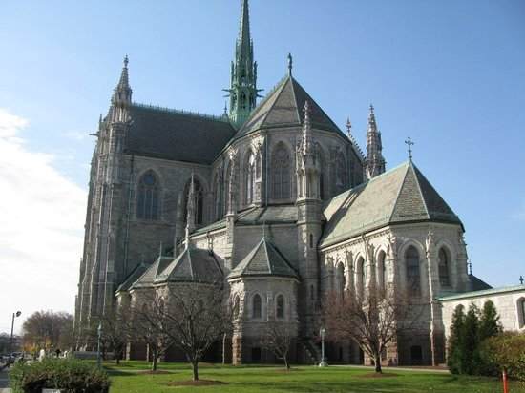

Have you ever visited our Cathedral? It is a magnificent architectural structure, the fifth-largest cathedral in North America, and is the seat of the Roman Catholic Archdiocese of Newark. You are invited to take this opportunity to experience this sacred place in our own archdiocese.

WHEN: Wednesday, October 26, 2016

Time: Leave St. Mary’s Parking Lot – 11:00 am.
(following Scripture Study)
Return 3:00 pm.

Program: 12:00 noon – 12:30 Music Presentation at Cathedral

12:30 pm. Tour led by knowledge-able Tour Guide

Please fill in form below and drop off in collection basket or return to Sister Georgette by Sunday, October 23.

--- ---- --- --- --- --- --- --- --- --- --- --- --- --- --- --- --- --- --- --- --- --- ----
Please return no later than Oct. 23

Name_________________________________Phone #_________

We will car-pool. If we need another car, are you willing to drive?

_______ Yes, I am willing to drive

